Images

Containers are lightweight ephemeral which has distinct named space

In Docker, a **volume** is a special mechanism for **persisting data** generated or used by Docker containers. Volumes are managed by Docker and stored outside the container’s filesystem, making them a reliable way to keep data even when the container is stopped or removed.

**Why use volumes?**

* **Persistence:** Data isn’t lost when the container stops or is deleted.
* **Decoupling:** Data exists independently of the container’s lifecycle.
* **Performance:** Volumes are more efficient than bind mounts in most cases.
* **Sharing:** Multiple containers can access the same volume.

3 types:-

* 1. TempFS
  2. Bind mount :-(Eg:- docker run -it -v /devan_container:/devan_cont ubuntu bash)
  3. Docker Volumes

1. Anonymous
2. Named

Named volume are better than bind mounts here it will be stored in /var/lib/volumes/volume_name

You can create also :- “ docker create volume volume_name “ so here it can be handle by docker

Here when we give only one parameter in “volume” then it take it as the container volume and in outside it will create an anonymous long named volume

“When write docker -–rm or - –true then it will kill after stop automaticaly”

Docker system prune

[“Multistage image??”]

IP Addressing

Ethernet Card

Root nic -eth0

Ethernet Cable

N/W Switch

Gateway

Nating/Dnat

Subnetting

Docker networks

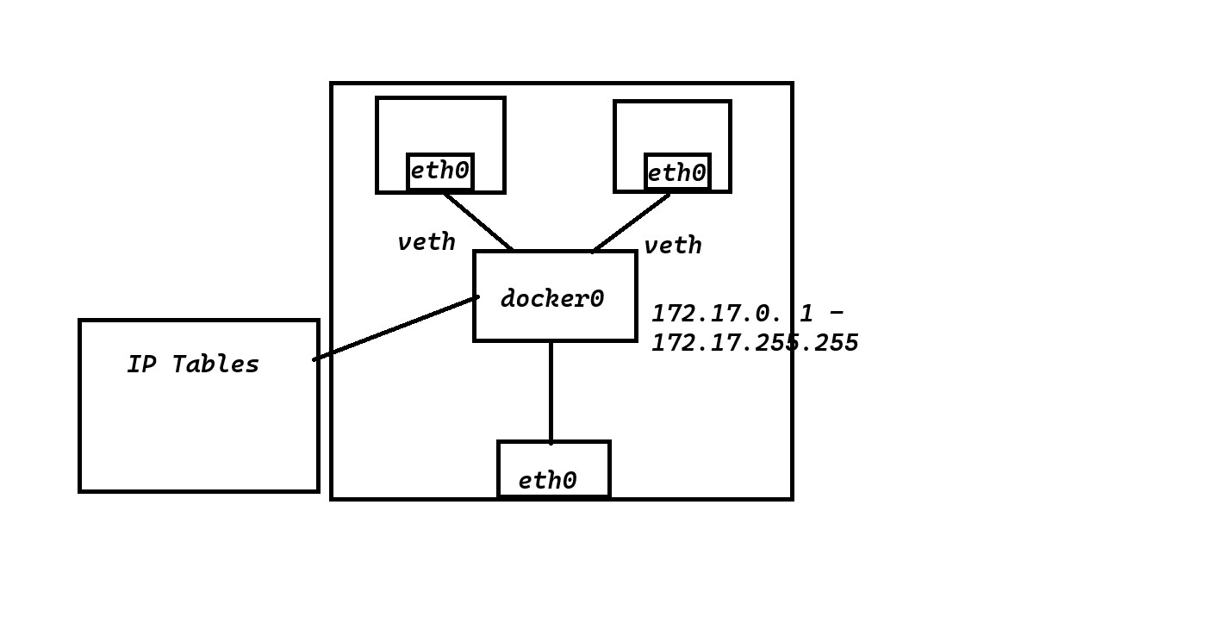

1. Bridge
2. Host
3. None

Host n/w :- here it will connect to the root so here it has host n/w.

[“Workdir”?]

Ipvlan

Maclan

Docker Compose

Here we can build and run

Here we can build an image, if image is there then can pull it also and it can start containers, Here we can make more than one containers.(The major feature is creating an image and container both step can be done through one step)

It will create a bridge n/w.

Dockercomposefile

services:

 web:

   build: .

   ports:

     - "8080:8080"

Here it will build Dockerfile if it exist in current dir otherwise need to give the path

To run: “ docker compose -f dc1.yaml up -d” #(up means running state ,d detach mode)

[“ \ in linux understand that line is not finished and make next line will be also there ”]

ab -> apache bench framework

“Docker swarn”

Here there will be a load balancer so there will be no error when do portforwarding because a loadbalancer will be there.